False.

Counterexample:

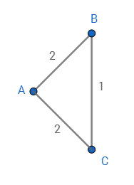

The shortest path tree rooted at A is

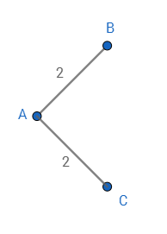

, which does not contain the edge (B, C).